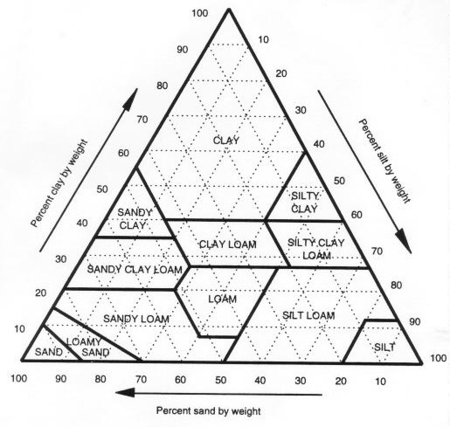

Plot the following percentages of soil textures.
Point | % Sand | % Clay | % Silt | Name of Texture
A | 35 | 35 | 30
B | 18 | 12 | 70
C | 70 | 15 | 15
D | 0 | 20 | 80

Name the percentages for the following points on the soil texture diagram
- % sand ___________ % clay _________________ % silt _______________
- % sand ___________ % clay _________________ % silt _______________
- % sand ___________ % clay _________________ % silt _______________
- % sand ___________ % clay _________________ % silt _______________

